Algorithms

Recursion

* The process in which a function calls itself directly or indirectly is called recursion and the corresponding function is called a recursive function.
* Recursion is an amazing technique with the help of which we can reduce the length of our code and make it easier to read and write

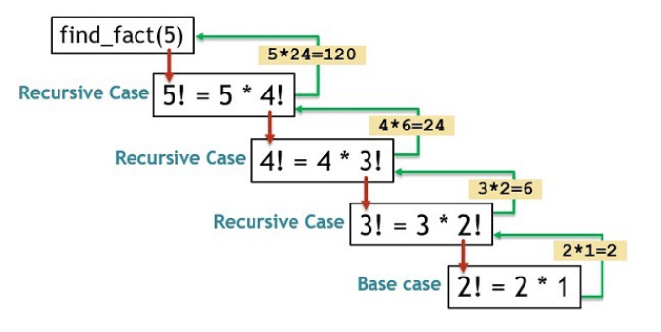

 Graph Traversal Algorithm

[Graph traversal](https://www.simplilearn.com/tutorials/data-structure-tutorial/graphs-in-data-structure) is a search technique for finding a vertex in a graph. In the search process, graph traversal is also used to determine the order in which it visits the vertices.

There are two methods to traverse a graph data structure:

* Depth-First Search or DFS algorithm
* [Breadth-First Search or BFS algorithm](https://www.simplilearn.com/tutorials/data-structure-tutorial/bfs-algorithm)



